Computer Programming using Python
Part 11 Intro to wxGlade
Overall goal: make a project, generate code, then run the code in IDLE

Create a wxGlade Project (Part11.wxg)
GOAL: To make an OK button that is between top and bottom of window
- Add Frame
- Right-click the small bar at the top then Add Slot
- Then do that again so there are 3 slots
- Click the button that adds buttons (says “OK”)
- Click in the middle slot (this adds the button to that slot)
- Save As, Part11.wxg
Generate Code (part11.pyw)
GOAL: Design a form then generate a pyw (python) program that will use the form
- Click “Application” in the wxGlade:Tree panel
- Scroll to the bottom of the properties window & type in part11.pyw for output path:
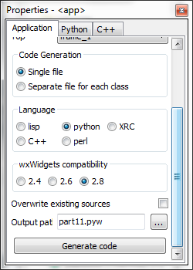
- Then click Generate Code

Open the code & Run it
- Open IDLE
- File, Open, part11.pyw
- Run, Run Module
- Show teacher that program is running

