Advanced Programming Using Java - acp4.1 - Lesson 7 (Chapter 4 Part A)
GOALS: Learn about and use Object, String, and Wrapper classes by making a drawing program.

- Open NetBeans. If there are any projects open, click “File,” “Close All Projects”
- File, New Project
  - Java, Java Application, Next
  - Change Project Name to “acp4”
  - Make sure project Location is your Home drive (such as, Browse to This PC, your username)
  - Uncheck “Create Main Class” so you can create your own window later
  - Finish
- With acp4 selected, click File, New File
  - Swing GUI Forms, JFrame Form, Next
  - Name the class MainForm
  - For “Project” make sure “acp4” is selected
  - For “Package” type “acp”
  - Finish
NOTE: In Java, comparing strings with == is not the same as the equals method. “==” compares their addresses. To compare two strings in Java, always use the equals method. EXAMPLE: string1.equals(string2)
Also, when comparing strings, such as for sorting, the string’s compareTo method sorts by ASCII values—numbers, uppercase letters, then lowercase letters (Teukolsky 178-179). Symbols are at various locations in the ASCII chart.

Various simple values such as numbers have Wrapper Classes. For example, a variable declared as int or Integer uses the Integer class. The purpose of the class is to provide simple access to related methods such as operators, comparison, and conversion.

Add drawing ability to the form:
- Make the form at least as big as the preview area
- Click the Source tab at the top
- In the MainForm class, add variables for the mouse location. Also save the old mouse state, so lines can be drawn so there are no gaps in the lines you draw:
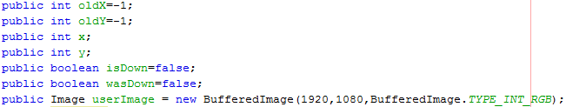
- Click the image line, the bulb, then java.awt.Image
- Same for java.awt.BufferedImage
(continue to next page)

Advanced Programming Using Java - acp4.2 - Lesson 7 (Chapter 4 Part A)

- In the MainForm constructor,after initComponents, fill the image (choose any color—it is black by default), and call addMouseMotionListener to add new listeners:
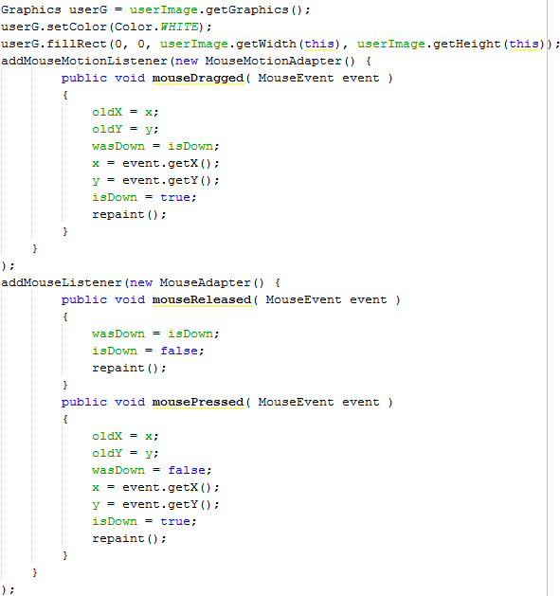 (Mehfuza)
- Click MouseMotionAdapter line, the bulb, then import java.awt.event.MouseMotionAdapter
- Click MouseEvent line, the bulb, then import java.awt.event.MouseEvent
- Click MouseAdapter line, the bulb, then import java.awt.event.MouseAdapter
- Override the paint method to draw more to the panel’s graphics object, by adding a paint method to MainForm: 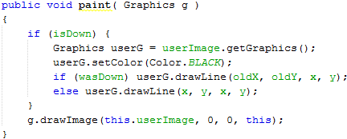
- Click Graphics line then the bulb, then import java.awt.Graphics; for Color line import java.awt.Color
- Run your program and make sure that you can draw on the form by clicking or dragging the mouse around.

