Advanced Programming Using Java - Lesson 1 (Ch. 1 Part A)
GOALS: Use Packages and Classes, Types and Identifiers, and Operators
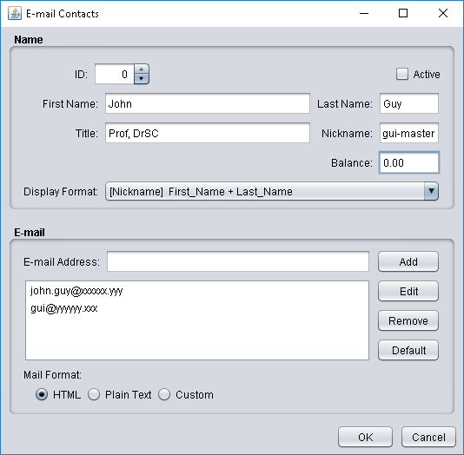
Create a new project:
- Open “NetBeans IDE”
- When the program opens, click “File,” “New Project”
- Samples, Java, GUI Form Examples, Next
- Name it acp1GUIFormExamples
  - For Project Location, click “Browse,” open This PC, double-click your username, Open
  - For “main class” select “ContactEditor”
  - Finish
(if you forgot to select main class, click the arrow by default config, then configure, then for Run, Browse and choose examples.ContactEditor
The main class is the class that opens when your program starts
- Click Run
Modify the program:
- Expand Source Packages, examples, ContactEditor.java
- Try changing the default to John Doe:
  - Click the white TextField by Last Name, and change text to Doe (in the Property panel on the right side)
- Currently, all of your options are strings (text). Let’s make fields with other datatypes as well:
  - int (An integer is a whole number—add a spinner with default increment decrement of -1 and 1 to ensure an integer is entered for the EmployeeID)
    - from the Palette panel on the right, drag a Spinner below the JTextField for Nickname, and drag a label to the left of it. Change horizontalAlignment of the label to RIGHT:
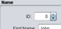
Click the label, then change the “text” (in Properties tab on right) to “ID”
  - boolean: boolean can only have two values, which can represent on or off (yes/no, true/false or other). This type of setting can be presented to the user as a checkbox.
    - Drag a CheckBox from the control Palette on the right. Change the text to “Active”:
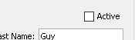
  - double: double-precision floating point value is one specific computer data type which can store a number with decimals—almost any useful Real Number.
    - This can be represented by a FormattedTextField (a field which forces a certain number of decimal places such as for money). Drag a FormattedTextField on the right, below the other fields, and add a label before it and make it say “Balance” (see picture on top right).
    - Select the blank text field you made, then in its “Properties” panel on the right, near the top of the list of values, click the value for “formatterFactory” 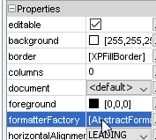 then choose Currency, OK. Change the text to 0.00

(Teukolsky 60)
You can see how the different operators work in Java and how to access form objects by identifiers (variable or function names) by making a calculator:
- File, New Project, Java, Java Application, Next
  - Name it acp1calc
  - Browse to your home drive and choose it (open)
  - Uncheck “Create Main Class” since we’ll create a form as the main class, then Finish
- Right-click acp1calc, New, Swing GUI Forms, JFrame Form
  - Name it MainForm
  - Call the package acp (or something else but not default)
  - Finish, then wait for the form to appear, and the “Loading…” text to disappear
- Construct a very simple calculator (see directions and picture):
  - Spinner, click Code tab (on bottom right panel), change Variable Name to spinner1
  - Five buttons. Change the text on each button’s Properties tab: + - * / %
  - another Spinner, change Variable Name to spinner2
  - Make a Text Field below the operands where your program can put the answer. Change then Variable Name in the Code tab to resultField
  - Make the form smaller to fit the gui elements you made (see picture)
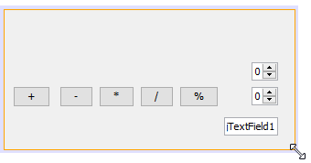
- Make event handlers to the math:
  - Double-click “+” button and change the code (as soon as you type each dot, a list of autotype options will appear, avoid typing those options by looking at the screen while you type or clicking the option after you type each dot and first letter after the dot)
- Run the program and see if it works (change spinners to 1 and 2 and see if clicking + makes 3 appear)
  - Once you get the program working, copy that line of code, and double-click each button. Paste then change ‘+’ to whatever the button is.
  - (if you forgot to uncheck create main class when you started, the blank mainclass program will run. To fix that problem, click the arrow by default config, then configure, then for Run, Browse and choose MainForm)

